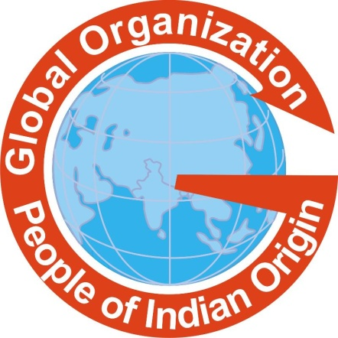

GOPIO 25th ANNIVERSARY CONVENTION TO BE HELD IN TRINIDAD & TOBAGO
The Global Organization of People of Indian Origin (GOPIO International) will be holding its 25th (Jubilee) Anniversary in Port of Spain in Trinidad & Tobago, with a 2-day gala celebration on 27th to 29th May, 2014 preceding the annual Indian Arrival Day commemoration in that country. GOPIO International Trinidad & Tobago Chapter will be the convention host, along with a well organized convention team which includes GOPIO's regional and international chapters, executives, councils and life members, as well as businesses, government, organizations and academic supporters.

Hosting of GOPIO 25th (Jubilee) Anniversary in Port of Spain has been enthusiastically endorsed and supported by the Government of Trinidad & Tobago, prominent persons of Indian origin and several chambers of commerce, businesses, organizations, academicians and academic institutions, media and others.

The strong relationship between GOPIO and Trinidad & Tobago began with the formation of GOPIO in 1989 with high level representation of several prominent persons from Trinidad & Tobago, as well as other countries of the Caribbean region. This relationship blossomed to continuing participation in GOPIO at the highest levels at GOPIO's major events and GOPIO's many visits to Trinidad & Tobago over the years. In addition, the International Chapter of Trinidad & Tobago is among the most active and vibrant of GOPIO's many chapters globally, addressing current and critical community issues such as spousal abuse, alcoholism, education, children and health concerns. GOPIO is proud to have hosted Trinidad and Tobago Prime Minister Kamla Persad Bissessar on 12th January, 2012 at special reception/dinner in Kolkata during her visit to India as the chief guest at Pravasi Bharatiya Divas 2012.

GOPIO chapters in the Caribbean region are: Trinidad & Tobago; Guyana; Suriname; St Vincent; Belize; Guadeloupe and Martinique, with others in formation in Jamaica, St Lucia, Grenada and Barbados. Recently, GOPIO has held and collaborated on several major conferences in the Caribbean region: Trinidad & Tobago (2011); St Vincent (2012); Suriname (2013); Guyana's 175th Indian Arrival Day Commemoration (2013); and Belize (2014). Minister Vayalar Ravi (India's Ministry of Overseas Indian Affairs) visited Trinidad & Tobago and other countries in the Caribbean region in 2007, 2011 and 2013. The program outline is as follows:

Program Outline

27th May | Welcome Reception & Dinner
28th May | GOPIO meetings  Business-to-Business meetings
28th May | Dinner & Cultural Evening
29th May | GOPIO All-Day Conference:  Economic Opportunities  Social Issues & Diaspora Sessions
29th May | Awards Banquet and Gala
30th May | Participation: Indian Arrival at Nelson Island
30th May | Participation: Indian Arrival Commemoration
30th May | Participation: NICC Cultural Evening
31st May - onwards | Tourism & Visits -  Tobago, Barbados, Aruba, Guyana, etc.

"We feel privileged and are fully prepared to host GOPIO 25th (Jubilee) Anniversary in 2014 in Port of Spain in grand style that is fitting and well deserved", said Ena Maraj, president of GOPIO International Trinidad& Tobago Chapter, who initiated the proposal to host the event.

Dr. Arnold Thomas, GOPIO International Coordinator (Caribbean Region) remarked that, "It is important to highlight this region of the Indian Diaspora, along with the many benefits and unique advantages of holding GOPIO's 25th (Jubilee) Anniversary in Port of Spain".

"We are planning a huge, historic 25th Jubilee Anniversary in Port of Spain never done before and will become memorable in GOPIO and the Indian Diaspora", said Deo Gosine, grand patron.

Ease of travel to and from Trinidad & Tobago regionally and internationally, excellent infrastructure, communications and accommodations, as well as enthusiastic support and encouragement from all sectors, helped to substantiate this proposal for Trinidad & Tobago as the perfect, most suitable venue and setting for GOPIO to celebrate its Jubilee in 2014. More details are forthcoming via newsletters and postings on GOPIO's website on:
Program Details
CSA Recognition
Registration- no cost for registration
Travel & Visa

Trinidad and Tobago is an independent island nation located just off the northern coast of South America, with a population of over 1,300,000 of which 45% are people of Indian origin whose ancestors were brought there as indentured sugar plantation laborers with the first arrivals on 30th May, 1845.

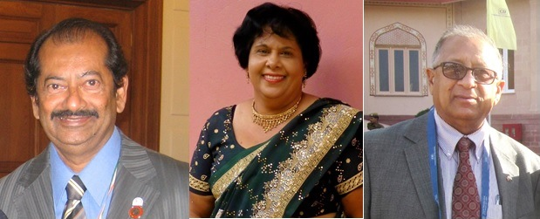
Photo above: GOPIO Convention organizers, From l. to r.: Dr. Arnold Thomas, Ena Maraj and Deo Gosine
For more information, please contact;
In Trinidad and Tobago
Ena Maraj (Convener): e.maraj@yahoo.com
Dr. Arnold Thomas (General Convener): arnoldthom@yahoo.co.uk
Deo Gosine (Grand Patron): deogosine@gmail.com

GOPIO INVITES NOMINATIONS FOR COMMUNITY SERVICE (CSA) AWARDs 2014

At the GOPIO Biennial Convention, those who have provided outstanding community service will be recognized at the finale banquet on May 29th evening. GOPIO is seeking nominations of suitably qualified candidates from the NRI/PIO community for consideration by GOPIO's 2014 Selection Committee. For more details and format for submission of nominations, please visit www.gopio.net.
Nominations are to be submitted using the prescribed form with supporting documents by April 4, 2014 to Chair, GOPIO 2014 Selection Committee at indersingh.usa@gmail.com.

